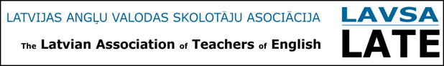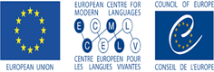
“Relating language curricula, tests and examinations to the Common European Framework of Reference (RELANG)”

Programme RELANG Workshop Module 1
“Alternative, continuous methods of assessment in line with the CEFR and its Companion Volume”
Latvia, 13-15 June 2022
Venue: Bellevue Park Hotel Riga, Slokas Street 1, Riga

13 June 2022
9:40 – 10:00 | - Registration
Morning session 1  10:00 – 11:30 | - Welcome & Introduction to the ECML (video)  - Presentation: Fundamentals of the CEFR and the Companion Volume  - An action-oriented approach  - Modes of communication (reception, production, interaction and mediation)
Break 11:30 – 11:50
Morning Session 2  11:50 – 13:20 | - Linking Phase 1 Familiarization: introduction  - Group work: ordering descriptors  - Presentation: What is alternative, continuous assessment?
Lunch 13:20 – 14:00
Afternoon Session 1  14:00 – 15:30 | - Presentation: Usefulness of alternative, continuous assessment  - Discussion
Break 15:30 – 15:50
Afternoon Session 2  15:50 – 17:20 | - Group work: linking alternative assessment to the curriculum  - Discussion
14 June 2022
Morning Session 1  09:00 – 10:30 | - Presentation: Examples of task types  - Group work on continuous assessment tasks in the local context  - Plenary discussion
Break 10:30 – 10:50
Morning Session 2  10:50– 12:20 | - Group work: developing a portfolio of tasks for continuous assessment focussing on four modes of communication and the relevant descriptors  - Discussion
Lunch 12:20 – 13:00
Afternoon Session 1  13:00– 14:30 | - Group work: Task design
Break 14:30 – 15:00
Afternoon Session 2  15:00 – 16:30 | - Group work (continued): Task design  - Plenary: presentation and discussion

15 June 2022
Morning Session 1  09:00 – 10:30 | - Presentation: assessment criteria and rating scales for alternative assessment Group work: developing rating scales for the tasks developed in the earlier session
Break 10:30 – 10:50
Morning Session 2  10:50 – 12:20 | - Group work (continued): developing rating scales for alternative ways of assessment
Lunch 12:20 – 13:00
Afternoon Session 1  13:00 – 14:30 | - Plenary: group presentations and discussion  - Reflection on potential strengths and weaknesses of continuous assessment
Break 14:30 – 15:00
Afternoon Session 2  15:00– 16:30 | - Conclusions of workshop

This initiative is carried out within the framework of a cooperation agreement between the European Centre for Modern Languages and the European Commission, entitled
Innovative Methodologies and Assessment in language learning
www.ecml.at/ec-cooperation

